**SUJEYTHARAN A/L SREEDARAN**

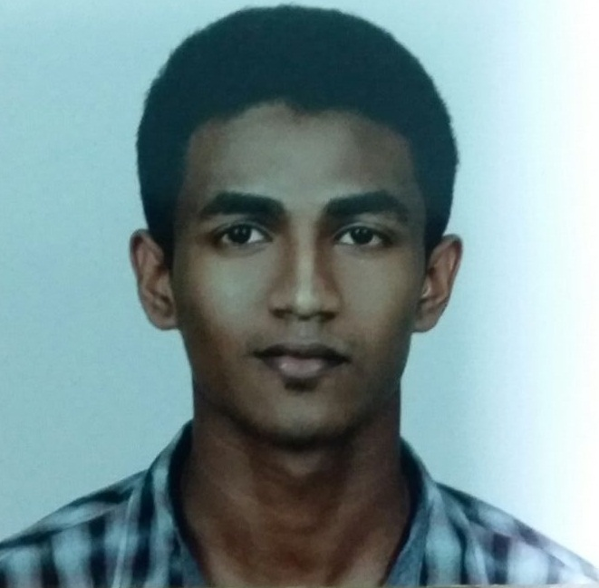

PE-00-02, BLOCK E,

JALAN WAWASAN 5/3,

PUSAT BANDAR PUCHONG,

47160, PUCHONG.

Contact Number: 014-9259903

sujeytharan94@gmail.com

**CAREER OBJECTIVE**

* Seeking challenging to learn and contribute to the growth of organization, hence becomes a leader in corporate strategy building and production management.
* To assume full time position with an established organization or a multinational company this provides challenges and opportunities for advancement projects involving and achievement.

**PERSONAL PARTICULARS**

Age : **23 years old**

Nationality : **Malaysian**

Marital Status : **Single**

Permanent Residence : **Malaysia**

Date of Birth : **02 JULY 1994**

Gender : **Male**

IC Number : **940702-10-6249**

Health : **Very Good**

**Work ing Experiences**

**Company 1**

Position : Sale & Marshall

Department : Escaperoom Puchong

Duration : 2014-2015

**Company 2**

Position : Customer Service & Sales

Department : Signature Fitness Puchong

Duration : 2016-2017

**Activities Attended**

* Achievement for completing in Police Cadet (2009- 2011)
* Achievement for completing in Community Policing Selangor (2011)
* Achievement for Malaysian School Football Council Petaling (2010-2011)

**ACADEMIC PROFILE**

Level : Degree

Major : Bachelors of Arts in Business and Management

Year : 2017- present

Institute / University : Segi College Subang Jaya / University of Sunderland

Current CGPA : 2.90

Level : Diploma

Major : Business Administration

Year : 2014-2016

Institute / University : Segi College Subang Jaya

Current CGPA : 2.89

Level : Certificate in Business

Institute / University : Segi College Subang Jaya

Year : 2012-2014

CGPA : 2.33

**PREFERENCES**

Willing to Relocate/Travel : Yes

Possess Own Transport : Yes

Valid Driving license : Yes

Availability : As soon as possible

Expected Salary for Internship : RM 600

**SKILL PROFILE**

* Excellent in typing skills.
* Strong analytical skills.
* Strong numerical skills.
* Microsoft Office.

**LANGUAGE PROFILE**

|  |  |  |
| --- | --- | --- |
| **Language** | **Spoken** | **Written** |
| 1. Bahasa Malaysia | 5 | 5 |
| 2. English | 5 | 5 |
| 3. Tamil | 5 | - |
| 4. Chinese | 5 | 3 |

Scale of 1 -5 (Good)

**PERSONAL OUTLOOK**

As a person, I’m a learning agility and effective personal communication skills.

Furthermore, I have a positive attitude, I can face any critical situation and always curious to learn about new thing. I’m punctual and hardworking. Whereas, I am a little feared but I willing to prevent it. I trust people easily. My weakness is that I cannot leave any work before its completion and easily.

**REFERENCES**

Name : Mr. Kenny

Position : Sale Executive

Company : Escaperoom Puchong

Contact No : 017-6162210

Name : Mr. Stanley

Position : Manager

Company : Signature Fitness Puchong

Contact No : 016-9613880